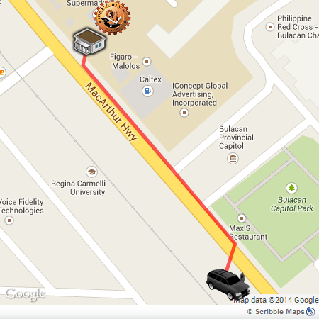
From Bulacan State University,
You can walk or ride by jeep to go to front of Bulacan Capitol Park (mini forest). Then go across the MacArthur Hwy, you can wait a transporting van there.

UV Express Service going to Cubao, MRT.
FARE: 60PHP

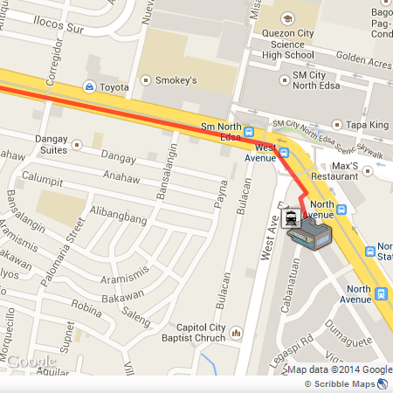

After arriving at MRT Trinoma (North Avenue), ask for a ticket for Buendia Station, then take a ride for Buendia Station.

MRT going to Buendia Station
FARE: 14 PHP

